Week – 6 Skill [V.SATHVIK,2520090097]

Task: Implement JWT-Based Authentication and Authorization Using FastAPI
Week_6_jwt_authentication/

└── main.py

main.py code:
from fastapi import FastAPI, HTTPException, Depends from fastapi.security import (
OAuth2PasswordBearer, OAuth2PasswordRequestForm
)
from jose import jwt app = FastAPI()
SECRET_KEY = "my-secret-key" ALGORITHM = "HS256"
oauth2_scheme = OAuth2PasswordBearer( tokenUrl="login"
)

@app.post("/login") def login(
form_data: OAuth2PasswordRequestForm = Depends()
):
if (
form_data.username == "Sathvik"
and form_data.password == "Sathvik123"
):
payload = {
"sub": form_data.username,

"role": "student"
}
token = jwt.encode( payload, SECRET_KEY,
algorithm=ALGORITHM
)
return {
"access_token": token, "token_type": "bearer"
}
raise HTTPException( status_code=401,
detail="Invalid username or password"
)

def get_current_user(
token: str = Depends(oauth2_scheme)
):
try:
payload = jwt.decode( token,
SECRET_KEY,
algorithms=[ALGORITHM]
)
return payload except Exception:
raise HTTPException( status_code=401,

detail="Invalid or expired token"
)
@app.get("/profile") def profile(
user=Depends(get_current_user)
):
return {
"message": "Welcome to your profile", "user_id": user["sub"],
"role": user["role"]
}

POST:
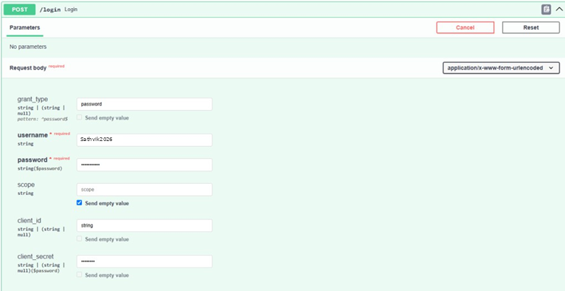

Response:
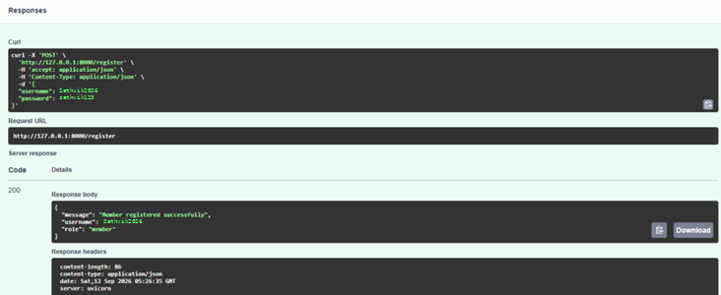

Authorization:
